# CPT_Logo_Manual.jpg Securing a Site Collection

**Lab Time**: 60 minutes

**Lab Overview:** In this lab you will practice modifying the permission settings at various levels of a SharePoint hierarchy. You will practice creating custom security objects and learn to employ them.

## Exercise 1: Disabling Permission Inheritance

In this exercise you will practice disabling permissions inheritance.

1. Log into your site collection using the account **Rob Walters**, a member of the Site Owners group with Full Control permissions to the site.
2. Using Internet Explorer, browse to the URL of the SharePoint site collection you were provided to use when working on the hands on labs in this course.
3. When prompted to login, enter [[AD-DOMAIN]]\rob in the **User Name** field and click **OK**. Use the password specified in the *Hands-On Lab Overview* document provided in the student manual.
4. Document the current permissions in effect:
5. Click the **Site Actions** hyperlink in the upper left corner of the page.
6. Click the **Site Permissions** link from the resulting Site Actions drop-down menu.
7. Is your site inheriting its permission set from its parent site?   
     
   **Yes \_\_\_\_\_\_ No \_\_\_\_\_\_**
8. Document the security **Principals** and their **Permission** assignments on the site:

\_\_\_\_\_\_\_\_\_\_\_\_\_\_\_\_\_\_\_\_\_\_\_\_\_\_\_\_\_\_\_\_\_\_\_\_\_\_\_\_\_\_\_\_\_\_\_\_\_\_\_\_\_\_\_\_\_\_\_\_\_\_\_\_\_\_\_\_\_\_\_\_\_\_\_\_\_\_

\_\_\_\_\_\_\_\_\_\_\_\_\_\_\_\_\_\_\_\_\_\_\_\_\_\_\_\_\_\_\_\_\_\_\_\_\_\_\_\_\_\_\_\_\_\_\_\_\_\_\_\_\_\_\_\_\_\_\_\_\_\_\_\_\_\_\_\_\_\_\_\_\_\_\_\_\_\_

\_\_\_\_\_\_\_\_\_\_\_\_\_\_\_\_\_\_\_\_\_\_\_\_\_\_\_\_\_\_\_\_\_\_\_\_\_\_\_\_\_\_\_\_\_\_\_\_\_\_\_\_\_\_\_\_\_\_\_\_\_\_\_\_\_\_\_\_\_\_\_\_\_\_\_\_\_\_

1. Click the hyperlink in the informational banner on the **Permissions** page to determine if there are any lists or libraries that have disabled inheritance in favor of unique permissions.

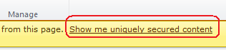

1. When the resulting **Exceptions** pop-up window appears, document the names of any lists or libraries on your site that use unique permissions then close the window.

\_\_\_\_\_\_\_\_\_\_\_\_\_\_\_\_\_\_\_\_\_\_\_\_\_\_\_\_\_\_\_\_\_\_\_\_\_\_\_\_\_\_\_\_\_\_\_\_\_\_\_\_\_\_\_\_\_\_\_\_\_\_\_\_\_\_\_\_\_\_\_\_\_\_\_\_\_\_\_\_

1. Navigate back to the home page of your lab site via the breadcrumb trail.
2. Your team has determined they need a special subsite that does not use the same permissions as your site to test new SharePoint layouts for the Sales department. Create a new subsite below your lab site called Sales:
3. Click the **All Site Content** link in the Quick Launch Bar then click the **Create** link in the toolbar.
4. In the resulting **Create** pop-up window scroll down to the bottom of the template listing and click on the **Team Site** button to select the template and click the **More Options** button to customize the site creation values.
5. The left pane of the window should have changed from a listing of different template choice buttons to the options page for a new team site. Fill in the values according to the Wingtip team's agreement as follows:

**Title:** Sales

**Description:** Security Lab test site

**URL Name:** sales

**User Permissions:** Use same permissions as parent site

**Use the top link bar from the parent site?** No

1. Click **Create** to finish creating the new site. After a brief progress pop-up the home page of the new site will automatically load in the browser.
2. Document the current permissions in effect on the new Sales site:
3. Click the **Site Actions** hyperlink in the upper left corner of the page.
4. Click the **Site Permissions** link from the resulting Site Actions drop-down menu.
5. Is the Sales site inheriting its permission set from its parent site?   
     
   **Yes \_\_\_\_\_\_ No \_\_\_\_\_\_**
6. Document the security **Principals** and their **Permission** assignments on the Sales site:

\_\_\_\_\_\_\_\_\_\_\_\_\_\_\_\_\_\_\_\_\_\_\_\_\_\_\_\_\_\_\_\_\_\_\_\_\_\_\_\_\_\_\_\_\_\_\_\_\_\_\_\_\_\_\_\_\_\_\_\_\_\_\_\_\_\_\_\_\_\_\_\_\_\_\_\_\_\_

\_\_\_\_\_\_\_\_\_\_\_\_\_\_\_\_\_\_\_\_\_\_\_\_\_\_\_\_\_\_\_\_\_\_\_\_\_\_\_\_\_\_\_\_\_\_\_\_\_\_\_\_\_\_\_\_\_\_\_\_\_\_\_\_\_\_\_\_\_\_\_\_\_\_\_\_\_\_

\_\_\_\_\_\_\_\_\_\_\_\_\_\_\_\_\_\_\_\_\_\_\_\_\_\_\_\_\_\_\_\_\_\_\_\_\_\_\_\_\_\_\_\_\_\_\_\_\_\_\_\_\_\_\_\_\_\_\_\_\_\_\_\_\_\_\_\_\_\_\_\_\_\_\_\_\_\_

1. Document the Permission Levels available for use on the Sales site:
2. Click the **Manage Parent** button in the **Inheritance** group **Edit** tab in the **Permission Tools** contextual tab in the ribbon.

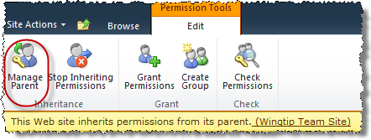

1. On the Permissions page of your lab site (the parent of the Sales site), click the **Permission Levels** button in the **Manage** group of the **Edit** tab in the **Permission Tools** contextual tab in the ribbon.

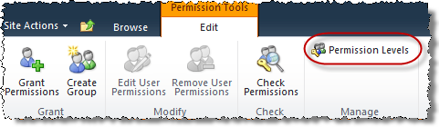

1. List the names of all of the **Permission Levels** available for use in your lab site's hierarchy:

\_\_\_\_\_\_\_\_\_\_\_\_\_\_\_\_\_\_\_\_\_\_\_\_\_\_\_\_\_\_\_\_\_\_\_\_\_\_\_\_\_\_\_\_\_\_\_\_\_\_\_\_\_\_\_\_\_\_\_\_\_\_\_\_\_\_\_\_\_\_\_\_\_\_\_\_\_\_

\_\_\_\_\_\_\_\_\_\_\_\_\_\_\_\_\_\_\_\_\_\_\_\_\_\_\_\_\_\_\_\_\_\_\_\_\_\_\_\_\_\_\_\_\_\_\_\_\_\_\_\_\_\_\_\_\_\_\_\_\_\_\_\_\_\_\_\_\_\_\_\_\_\_\_\_\_\_

\_\_\_\_\_\_\_\_\_\_\_\_\_\_\_\_\_\_\_\_\_\_\_\_\_\_\_\_\_\_\_\_\_\_\_\_\_\_\_\_\_\_\_\_\_\_\_\_\_\_\_\_\_\_\_\_\_\_\_\_\_\_\_\_\_\_\_\_\_\_\_\_\_\_\_\_\_\_

1. Navigate back to the Sales site.
2. Disable permissions inheritance on the Sales site:
3. Click the **Site Actions** hyperlink in the upper left corner of the Sales site's default page.
4. Click the **Site Permissions** link from the resulting Site Actions drop-down menu.
5. Click the **Stop Inheriting Permissions** button in the **Inheritance** group of the **Edit** tab in the **Permission Tools** contextual tab in the ribbon.

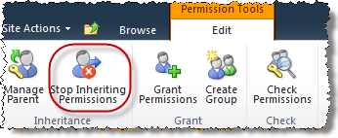

1. Click **OK** to the pop-up warning that permissions changes made at your lab site (the parent) will no longer impact the Sales site (the child) once you confirm:

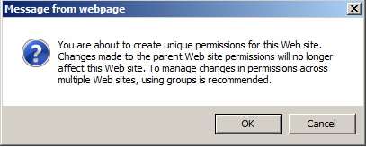

1. Notice that the permissions that used to be getting inherited from the parent are now appearing as permissions assigned here at the Sales site explicitly (they are hyperlinks with checkboxes and the Edit ribbon has changed). Click the **Permission Levels** button in the **Manage** group of the **Edit** tab in the **Permission Tools** contextual tab in the ribbon.
2. Notice that while the actual permission assignments are now being managed at the **Sales** site, the **Permission Levels** available for use are still being inherited from the parent, your site:

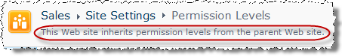

In this exercise you learned to disable permissions inheritance.

## Exercise 2: Customizing Security

In this exercise you will practice creating new security objects and customizing security.

1. Create some new security groups.
2. Authenticate into the library as Ken Sanchez using the **Welcome Menu** in the top right corner and select **Sign in as Different User** and enter [[AD-DOMAIN]]\ken for the user name and click **OK**.
3. Click **New** on the toolbar to create the first group. Name it “**Sales Meeting Owners**”, leave description blank, use Browse button to set owner to **Wingtip Team Site Owners**, leave other settings their default values except give this group the **Full Control** permission level then click **Create**.
4. At resulting group page, click the **Groups** header in the Quick Launch Bar to return to the All Groups page.
5. Repeat use of **New** button on toolbar to create the second group. Name it “**Sales Meeting Members**”, leave description blank, use Browse button to set owner to **Wingtip Team Site Owners**, leave other settings their default values except give this group the **Contribute** permission level then click **Create**.
6. At resulting group page, click **New** on the toolbar to add users to the group and type **SBO\Michael** into the **Users/Groups** box, **deselect** the **Send Email** checkbox and Click **OK** to add Michael as a member to Sales Meeting Members.
7. At resulting group page, click the **Groups** header in the Quick Launch Bar to return to the All Groups page.
8. Repeat use of **New** button on toolbar to create the second group. Name it “**Sales Meeting Visitors**”, leave description blank, use **Browse** button to set owner to **Wingtip Team Site Owners**, leave other settings their default values except give this group the **Read** permission level then click **Create**.
9. At resulting group page, click **New** on the toolbar to add users to the group and type **SBO\Janice** into the **Users/Groups** box, **deselect** the **Send Email** checkbox and Click **OK** to add Janice as a member to Sales Meeting Visitors.
10. At resulting group page, click the **Groups** header in the Quick Launch Bar to return to the All Groups page.
11. Authenticate into the library as Rob Walters using the **Welcome Menu** in the top right corner and select **Sign in as Different User** and enter [[AD-DOMAIN]]\rob for the user name and click **OK**.
12. Your team has dictated that they need the Owners, Members and Visitors groups to reflect the name of the Sales site (not its parent) and that the memberships of these groups will not be the same as similar groups on the parent site.
13. Click the **Site Settings** link in the breadcrumb trail, then click the **People and Groups** link under the **Users and Permissions** heading.
14. Click the **More...** hyperlink in the Quick Launch Bar under the **Groups** heading.

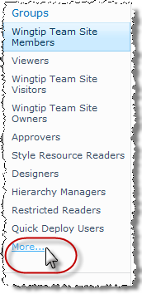

1. Click the **Edit Item** button to the right of the **Sales Meeting Visitors** group to rename the group.

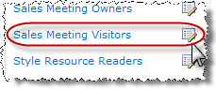

1. On the **Change Group Settings** page change the group owner to **Rob Walters** and click **OK**.
2. Use your newly acquired skills to repeat the above procedure update the **Sales Meeting Members** group owner to **Rob Walters** and click **OK**.
3. Use your newly acquired skills to repeat the above procedure update the **Sales Meeting Owners** group owner to **Rob Walters** and click **OK**.
4. Change the membership of the renamed groups:
5. Click the **Sales Meeting Visitors** hyperlink in the Quick Launch Bar under the **Groups** heading (you may need to click **More…** to get to the full list).
6. Check the selection box for the existing member of this group, Janice Galvin, and in the toolbar select **Actions » Remove Users from Group.** If prompted to confirm the action, click **OK**.

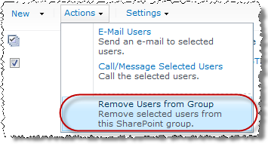

1. Click the **Sales Meeting Members** hyperlink in the Quick Launch Bar under the **Groups** heading (you may need to click **More…** to get to the full list).
2. Click the **New** button from the toolbar.
3. In the pop-up **Grant Permissions** box, enter **Janice** and click the **Check Names** icon in the lower right corner under the field. The name in the field should resolve to **Janice Galvin** or her login name. Click **OK**.

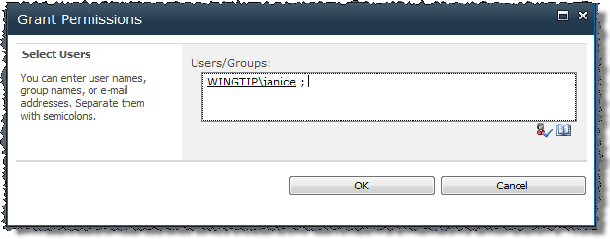

1. Check the selection box for the previous member of this group, Michael Sullivan, and click the **Actions** drop-down button from the toolbar. **BE SURE ONLY MICHAEL IS CHECKED.**
2. Choose **Remove Users from Group** and if prompted,click **OK** to the pop-up confirmation.
3. Use your newly acquired skills to edit the membership of the **Sales Meeting Owners** group to only the **Rob Walters** account.
4. Your team has indicated that they need a new security group **Principal** for the **Sales** team named **Salespeople** that should contain Jill Williams and Brian Cox as members:
5. Click the **More...** hyperlink in the Quick Launch Bar under the **Groups** heading.
6. Click the **New** link in the toolbar above the list of **Principals**.

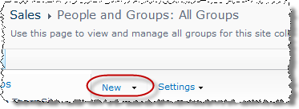

1. On the **Create Group** page enter the following values for the new group and click **Create**:

**Name:** Salespeople

**About Me:** Use this group to grant salespeople special permissions to the SharePoint site: Sales

**Group Owner:** Rob Walters

**Choose the Permission Level:** Read - Can view pages and list items and download documents.

1. On the new **Salespeople** group's page, click the **New** button from the toolbar.
2. In the pop-up **Grant Permissions** box, enter **Brian;Jill** and click the **Check Names** icon in the lower right corner under the field. The names in the field should resolve to Jill Williams and Brian Cox. Click **OK**.

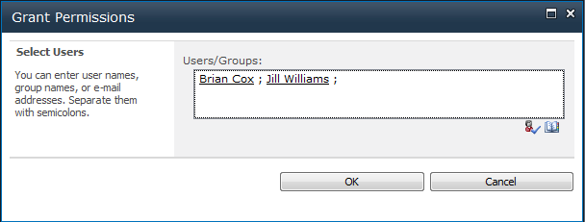

1. Verify that Jill Williams and Brian Cox are now listed as members in the Salespeople group.
2. Test the new Salespeople group:
3. Navigate to the default page of the **Sales** site via the breadcrumb trail.
4. Authenticate into the library as Brian Cox using the **Welcome Menu** in the top right corner and select **Sign in as Different User** and enter [[AD-DOMAIN]]\brian for the user name and click **OK**.
5. Verify that Brian can read but not contribute to the Sales site.
6. Authenticate into the library as Jill Williams using the **Welcome Menu** in the top right corner and select **Sign in as Different User** and enter [[AD-DOMAIN]]\jill for the user name and click **OK**.
7. Verify that JIll also can read but not contribute to the Sales site.
8. Authenticate into the library as Rob Walters using the **Welcome Menu** in the top right corner and select **Sign in as Different User** and enter [[AD-DOMAIN]]\rob for the user name and click **OK**.
9. Your team has indicated that they need the new Salespeople group to grant its members a special permission mix that is essentially contribute with the added ability to override checkouts and approve items.
10. Navigate to the Wingtip Team Site (the site collection top level site) via the Navigate Up button
11. Authenticate into the library as Ken Sanchez using the **Welcome Menu** in the top right corner and select **Sign in as Different User** and enter [[AD-DOMAIN]]\ken for the user name and click **OK**.
12. Click the **Site Actions** hyperlink in the upper left corner of the page.
13. Click the **Site Permissions** link from the resulting Site Actions drop-down menu.
14. Click the **Permission Levels** button in the **Manage** group of the **Edit** tab in the **Permission Tools** contextual tab in the ribbon.

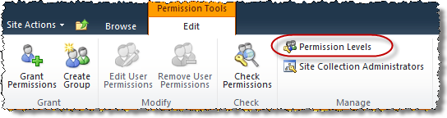

1. Click on the name of the **Contribute** permission level, scroll to the bottom of the permission level's settings and click the **Copy Permission Level** button. Use the following to create the new permission level:

**Name:** Sales Contribute

**Description:** Contribute plus override check out and approve items for Sales testing purposes only.

1. Check the boxes for the **Override Check Out** and the **Approve Items** permissions under the **List Permissions** heading.
2. Click **Create** to finish creating the new Permission Level object.
3. Navigate to the default page of the Sales site.
4. Click the **Site Actions** hyperlink in the upper left corner of the page.
5. Click the **Site Permissions** link from the resulting Site Actions drop-down menu.
6. Check the selection box for the Salespeople group and click the **Edit User Permissions** button from the **Modify** group of the **Edit** tab in the **Permission Tools** contextual tab in the ribbon.

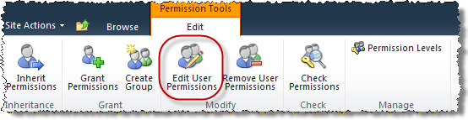

1. In the resulting **Edit Permissions** pop-up, check the new **Sales Contribute** permission level and clear the **Read permission level's** checkbox before clicking **OK** to complete the edit.

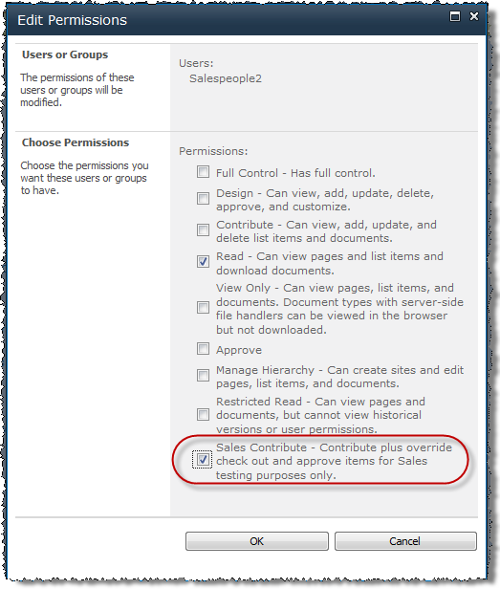

1. Verify that the Salespeople group now uses the Sales Contribute permission level:

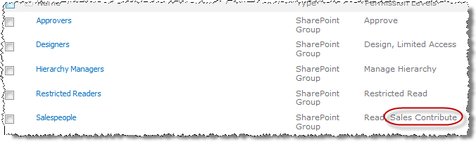

In this exercise you learned to create new security objects and customize security.

## Exercise 3: Re-establish Inheritance

In this exercise you will learn to re-establish permissions inheritance.

1. Your team is done testing the authority for the Sales project and has asked you to reset the Sale site to inherit its permissions from its parent site.
2. Click the **Inherit Permissions** button from the **Inheritance** group of the **Edit** tab in the **Permission Tools** contextual tab in the ribbon.

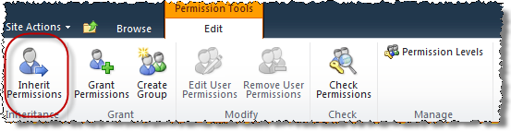

1. Click **OK** to the resulting pop-up warning stating that changing to inherited permissions may alter your custom security and render the site unavailable to users.

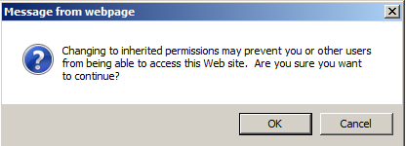

1. Click **OK** to finish creating the new view. The library should automatically switch to the new view.

In this exercise you practiced re-establishing permissions inheritance.

## Exercise 4: Controlling SharePoint Designer 2010 Usage

In this exercise you will learn how to manage how users of the site collection can use SharePoint Designer 2010 in a site collection.

1. Navigate to the Wingtip Team Site site collection using your preferred method.
2. From the ribbon, select Site **Actions » Site Settings**.
3. Towards the bottom of the **Site Collection Administration** section, find the link **SharePoint Designer Settings** and click it.
4. The SharePoint Designer Settings page will allow site collection administrators to lock down some of the capabilities of SharePoint Designer 2010. These same settings are available to farm administrators within Central Administration on a Web application by Web application basis. If the farm administrator grants one of these capabilities, site collection owns can elect to either leave it enabled or remove the capability. However site collection administrators cannot override a denial by a farm administrator if a capability is blocked:

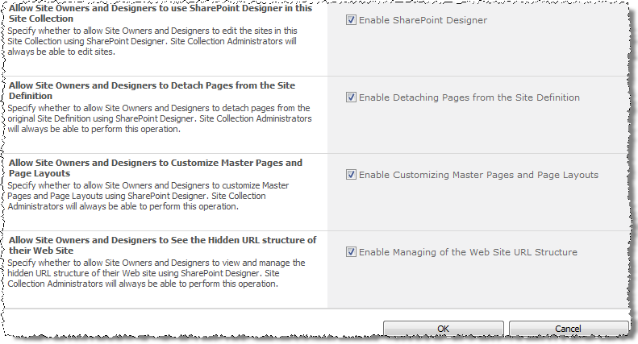

**Note:** For the remainder of this exercise you will need SharePoint Designer 2010 installed on your machine.

1. Before making any changes, try opening the site collection with SharePoint Designer 2010.
2. Launch SharePoint Designer 2010 (**Start » All Programs » SharePoint » Microsoft SharePoint Designer 2010**).
3. Click the **Open Site** button and enter the URL of your site collection:

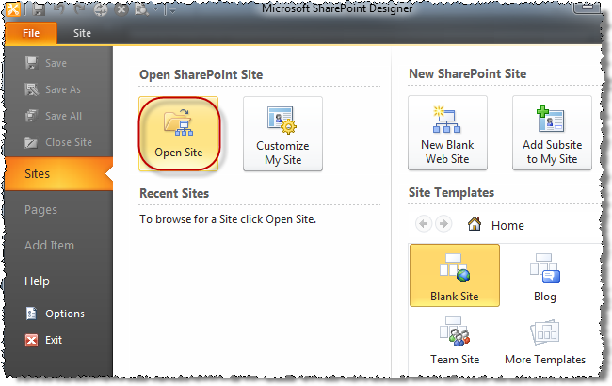

1. After a login prompt and a few moments, SharePoint Designer 2010 should open the site collection:

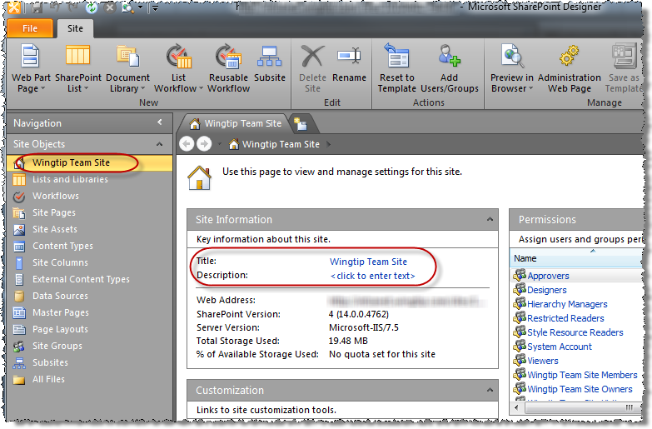

1. Now close SharePoint Designer 2010.
2. Lock down the Wingtip Site Collection from using SharePoint Designer 2010. From the **SharePoint Designer Settings** page in the browser, uncheck the option **Enable SharePoint Designer** and click **OK**.
3. Now try to open the site in SharePoint Designer 2010:
4. Launch SharePoint Designer 2010 (**Start » All Programs » SharePoint » Microsoft SharePoint Designer 2010**).
5. Click the **Open Site** button and enter the URL of your site collection.
6. When prompted to login, use Rob Walters [[AD-DOMAIN]]\rob. Use the password specified in the *Hands-On Lab Overview* document provided in the student manual.
7. Notice this time SharePoint Designer 2010 will not open the site:

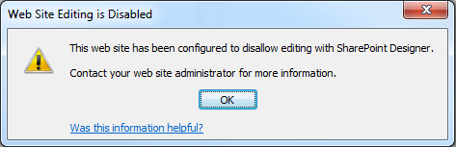

In this exercise you learned how to manage how users of the site collection can use SharePoint Designer 2010 in a site collection.